Project Planning Phase
Project Planning Template (Product Backlog, Sprint Planning, Stories, Story points)

Date | 28 September 2026
Team ID | SWTID-2026-1668
Project Name | Streamlining IT Procurement: Automating Standard Laptop Orders With Flow Designer
Maximum Marks | 5 Marks

Product Backlog, Sprint Schedule, and Estimation (4 Marks)
Use the below template to create product backlog and sprint schedule
Sprint | Functional Requirement (Epic) | User Story Number | User Story / Task | Story Points | Priority | Team Members
Sprint-1 | Environment Setup | USN-1 | As an admin, I can set up the ServiceNow instance with the required roles and groups (employees, managers, IT procurement team). | 3 | High | Karthika R
Sprint-1 | Service Catalog | USN-2 | As an employee, I can see a "Standard Laptop Request" item in the Service Catalog. | 5 | High | Brindha S
Sprint-1 |  | USN-3 | As an employee, I can fill in the request form (laptop model, justification, delivery location) and submit it. | 5 | High | Janani P
Sprint-1 | Flow Designer Automation | USN-4 | As an admin, I can create a Flow Designer flow that triggers when a laptop request is submitted. | 5 | High | Karthika R
Sprint-1 |  | USN-5 | As an employee, I receive an acknowledgement notification once my request is submitted. | 2 | Medium | Kanimozhi P
Sprint-2 | Manager Approval | USN-6 | As a manager, I receive an approval request when my team member raises a laptop request. | 5 | High | Parameshwari V
Sprint-2 |  | USN-7 | As a manager, I can approve or reject the request from the notification or the approval list. | 3 | High | Brindha S
Sprint-2 |  | USN-8 | As an employee, I am notified when my request is approved or rejected. | 3 | High | Janani P
Sprint-2 | Task Creation | USN-9 | As an IT procurement team member, a catalog task is created and assigned to my group once the request is approved. | 5 | High | Karthika R
Sprint-2 |  | USN-10 | As an employee, I see my request closed automatically with a reason when it is rejected. | 4 | Medium | Kanimozhi P
Sprint-3 | Order Fulfilment | USN-11 | As an IT procurement team member, I can update the task with order details (vendor, order ID, expected delivery date). | 5 | High | Brindha S
Sprint-3 |  | USN-12 | As an employee, I can track the status of my laptop request from the portal. | 5 | Medium | Janani P
Sprint-3 |  | USN-13 | As an employee, I am notified when my laptop is delivered. | 3 | Medium | Parameshwari V
Sprint-3 |  | USN-14 | As an admin, the request is closed automatically once the IT task is completed. | 4 | High | Karthika R
Sprint-3 | Error Handling | USN-15 | As an admin, I am alerted when the flow fails or no manager is found for the requester. | 3 | Medium | Kanimozhi P
Sprint-4 | Testing | USN-16 | As a tester, I can test the flow end to end for approved and rejected scenarios using Flow Designer test mode. | 5 | High | Parameshwari V
Sprint-4 | Reporting | USN-17 | As an IT manager, I can view a report of laptop requests by status. | 5 | Medium | Brindha S
Sprint-4 | Deployment | USN-18 | As an admin, I can move the catalog item and flow to production using an update set. | 4 | High | Karthika R
Sprint-4 | Documentation | USN-19 | As a user, I can refer to a short guide on how to raise a laptop request. | 3 | Low | Janani P
Sprint-4 |  | USN-20 | As a team, we prepare the final demo and project documentation. | 3 | Medium | Kanimozhi P

Project Tracker, Velocity & Burndown Chart: (4 Marks)
Sprint | Total Story Points | Duration | Sprint Start Date | Sprint End Date (Planned) | Story Points Completed (as on Planned End Date) | Sprint Release Date (Actual)
Sprint-1 | 20 | 6 Days | 28 Sep 2026 | 03 Oct 2026
Sprint-2 | 20 | 6 Days | 05 Oct 2026 | 10 Oct 2026
Sprint-3 | 20 | 6 Days | 12 Oct 2026 | 17 Oct 2026
Sprint-4 | 20 | 6 Days | 19 Oct 2026 | 24 Oct 2026

Velocity:
Imagine we have a 10-day sprint duration, and the velocity of the team is 20 (points per sprint). Let’s calculate the team’s average velocity (AV) per iteration unit (story points per day)

For this project, the sprint duration is 6 days and the team velocity is 20 story points per sprint, so the average velocity (AV) = 20 / 6 ≈ 3.33 story points per day.

Burndown Chart:
A burn down chart is a graphical representation of work left to do versus time. It is often used in agile software development methodologies such as Scrum. However, burn down charts can be applied to any project containing measurable progress over time.
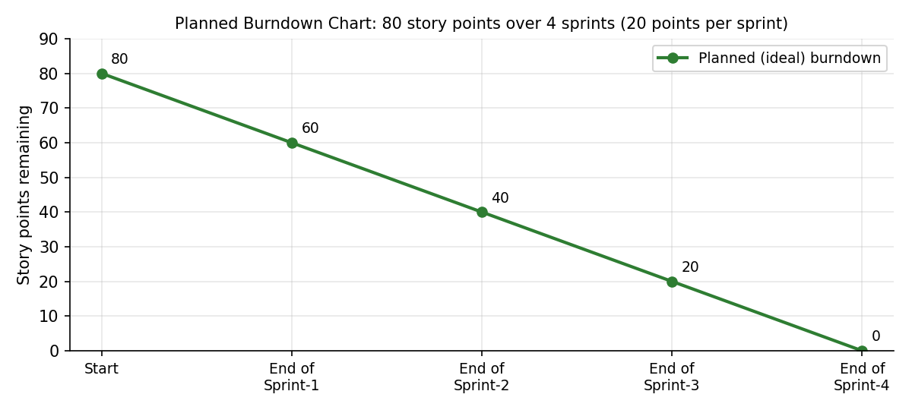

https://www.visual-paradigm.com/scrum/scrum-burndown-chart/
https://www.atlassian.com/agile/tutorials/burndown-charts

Reference:
https://www.atlassian.com/agile/project-management
https://www.atlassian.com/agile/tutorials/how-to-do-scrum-with-jira-software
https://www.atlassian.com/agile/tutorials/epics
https://www.atlassian.com/agile/tutorials/sprints
https://www.atlassian.com/agile/project-management/estimation
https://www.atlassian.com/agile/tutorials/burndown-charts

